Q.1 How to identify the Records (Order ID + Product ID combination) present in data1 but missing in data2 (Specify the number of records missing in your answer)
SQL Query:
select *
from data1 d1
left join data2 d2
on d1.`Order ID`=d2.`Order ID` and d1.`Product ID`=d2.`Product ID`
where d2.`Order ID` is null;

Select count(*) as Total_Missing
from data1 d1
left join data2 d2
on d1.`Order ID`=d2.`Order ID` and d1.`Product ID`=d2.`Product ID`
where d2.`Order ID` is null;

Output:
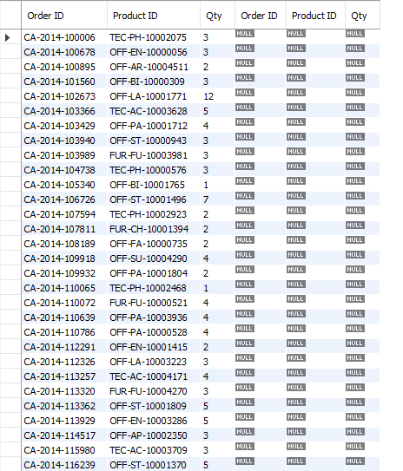

Q.2 How to identify the Records (Order ID + Product ID combination) missing in data1 but present in data2 (Specify the number of records missing in your answer)

SQL Query:

select *
from data1 as d1
right join data2 as d2
on d1.`Order ID`=d2.`Order ID` and d1.`Product ID`=d2.`Product ID`
where d1.`Order ID` is null;

select count(*)
from data1 as d1
right join data2 as d2
on d1.`Order ID`=d2.`Order ID` and d1.`Product ID`=d2.`Product ID`
where d1.`Order ID` is null;

Output:
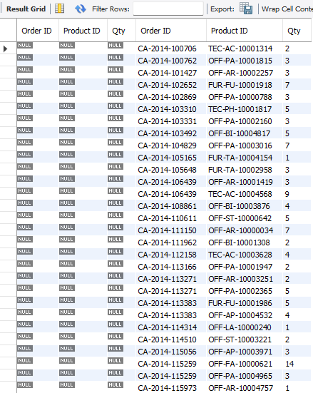

Q.3 Find the Sum of the total Qty of Records missing in data1 but present in data2

SQL Query:

Select sum(d2.QTY)
from data1 as d1
right join data2 as d2
on d1.`Order ID`=d2.`Order ID` and d1.`Product ID`=d2.`Product ID`
where d1.`Order ID` is null;

Output:



Q.4 Find the total number of unique records (Order ID + Product ID combination) present in the combined dataset of data1 and data2.

select count(*) as Total_Number
from
(select * from data1
union
select * from data2) as Combine;

Output:



